Data Operations - Transaction

Definition
# Source: AI Source: Provided by: [Data Path: Persons Table -> ID Column: 1, Name_En Column: Motasem Essam] -> From: [Chatgpt (GPT‑5 Mini)] on [12/10/2025]
Transaction is a sequence of one or more operations performed on data as a single logical unit of work.
- Either all operations are completed successfully, or none are applied.
- It ensures data consistency and reliability in a system.
Key idea:
A transaction follows the concept of “all or nothing.”

Properties of Transactions (ACID)
# Source: AI Source: Provided by: [Data Path: Persons Table -> ID Column: 1, Name_En Column: Motasem Essam] -> From: [Chatgpt (GPT‑5 Mini)] on [12/10/2025]
1️⃣ Atomicity
- The transaction is treated as one unit.
- If one part fails, the entire transaction fails.
2️⃣ Consistency
- The database remains in a valid state before and after the transaction.
3️⃣ Isolation
- Transactions are executed independently without affecting each other.
4️⃣ Durability
- Once a transaction is completed, the changes are permanently saved.

How Transactions Work
# Source: AI Source: Provided by: [Data Path: Persons Table -> ID Column: 1, Name_En Column: Motasem Essam] -> From: [Chatgpt (GPT‑5 Mini)] on [12/10/2025]
- Begin the transaction
- Execute operations (insert, update, delete, etc.)
- Check for errors
- Commit (save changes) if successful
- Rollback (undo changes) if something fails

Commit
# Source: AI Source: Provided by: [Data Path: Persons Table -> ID Column: 1, Name_En Column: Motasem Essam] -> From: [Chatgpt (GPT‑5 Mini)] on [12/10/2025]
Definition:
Commit is the process of saving all changes made during a transaction permanently in the database.
Key idea:
Once a transaction is committed, the changes cannot be undone.
What happens during Commit:
- All operations in the transaction are successfully completed
- Changes are written permanently to the database
- The system confirms the transaction is finished
Example:
- You transfer money between two accounts
- Both debit and credit operations succeed
- Then the system commits the transaction → changes are saved permanently

Rollback
# Source: AI Source: Provided by: [Data Path: Persons Table -> ID Column: 1, Name_En Column: Motasem Essam] -> From: [Chatgpt (GPT‑5 Mini)] on [12/10/2025]
Definition:
Rollback is the process of undoing all changes made during a transaction if something goes wrong.
Key idea:
Rollback restores the database to its previous state before the transaction started.
What happens during Rollback:
- An error or failure occurs in the transaction
- All changes made in the transaction are canceled
- The database returns to its original state
Example:
- You transfer money
- The amount is deducted from Account A
- But adding it to Account B fails
- The system performs a rollback → money is restored to Account A

Types of Transactions

1️⃣ Single Transaction
# Source: AI Source: Provided by: [Data Path: Persons Table -> ID Column: 1, Name_En Column: Motasem Essam] -> From: [Chatgpt (GPT‑5 Mini)] on [12/10/2025]
- One set of operations treated as a unit
- Example: transferring money between two accounts

2️⃣ Distributed Transaction
# Source: AI Source: Provided by: [Data Path: Persons Table -> ID Column: 1, Name_En Column: Motasem Essam] -> From: [Chatgpt (GPT‑5 Mini)] on [12/10/2025]
- A transaction that involves multiple systems or databases
- Example: processing an order across different servers

Example
# Source: AI Source: Provided by: [Data Path: Persons Table -> ID Column: 1, Name_En Column: Motasem Essam] -> From: [Chatgpt (GPT‑5 Mini)] on [12/10/2025]
Bank Transfer Example:
- Transfer $100 from Account A to Account B
Steps:
- Deduct $100 from Account A
- Add $100 to Account B
- If step 2 fails → step 1 is reversed (rollback)
- This ensures no money is lost or duplicated

Example in Database
# Source: AI Source: Provided by: [Data Path: Persons Table -> ID Column: 1, Name_En Column: Motasem Essam] -> From: [Chatgpt (GPT‑5 Mini)] on [12/10/2025]
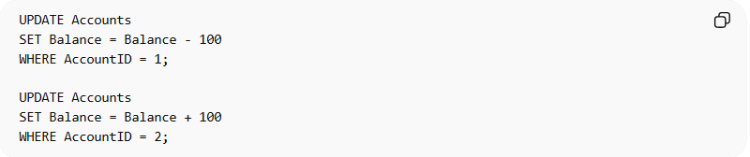
UPDATE Accounts
SET Balance = Balance - 100
WHERE AccountID = 1;

UPDATE Accounts
SET Balance = Balance + 100
WHERE AccountID = 2;
- Both queries must succeed for the transaction to be committed
- If one fails → both are undone

Key Characteristics
# Source: AI Source: Provided by: [Data Path: Persons Table -> ID Column: 1, Name_En Column: Motasem Essam] -> From: [Chatgpt (GPT‑5 Mini)] on [12/10/2025]
- Ensures data integrity
- Follows ACID properties
- Groups multiple operations into one unit
- Prevents partial updates
- Maintains consistency in databases

Advantages
# Source: AI Source: Provided by: [Data Path: Persons Table -> ID Column: 1, Name_En Column: Motasem Essam] -> From: [Chatgpt (GPT‑5 Mini)] on [12/10/2025]
- Prevents data inconsistency
- Ensures reliability of operations
- Protects against system failures
- Maintains accuracy of data
- Supports safe multi-step operations

Disadvantages
# Source: AI Source: Provided by: [Data Path: Persons Table -> ID Column: 1, Name_En Column: Motasem Essam] -> From: [Chatgpt (GPT‑5 Mini)] on [12/10/2025]
- Can be complex to implement
- May slow down system performance
- Requires more system resources
- Deadlocks can occur in complex systems
- Requires careful error handling

Summary
# Source: AI Source: Provided by: [Data Path: Persons Table -> ID Column: 1, Name_En Column: Motasem Essam] -> From: [Chatgpt (GPT‑5 Mini)] on [12/10/2025]
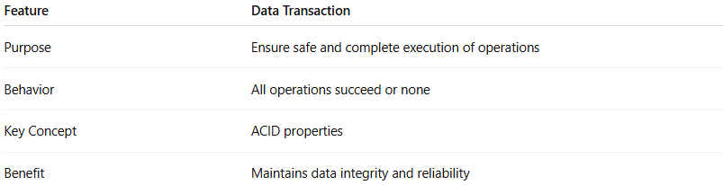
Feature | Data Transaction
Purpose | Ensure safe and complete execution of operations
Behavior | All operations succeed or none
Key Concept | ACID properties
Benefit | Maintains data integrity and reliability

